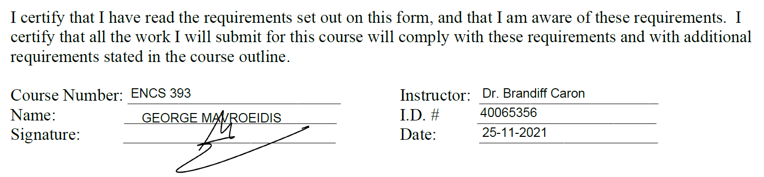

Australia’s Loyal Wingman Program and its ethical dilemma on future warfare

Warfare has evolved rapidly since the beginning of The Great War. In the past, wars were fought traditionally, meaning minimal technology assistance and close combat action between hundreds of thousands of soldiers. Technology has affected the accuracy and risk of many strategic decisions, making every action more calculated and precise. Tactically, a military’s objective is to inflict damage to their opponents with the least amount of risk to their own soldiers. The purpose of technology in the military aims to remove the decision maker from the actual act of violence as much as possible, minimizing the loss of life and cost from their side. The majority of current conflicts relate to the war on terror, which is unlike other past conflicts. The battlefields are often established within civilian zones and are fought through small skirmishes, unlike trench warfare. Drone technology is proposed as the primary method to engage in this tactical context that avoids personnel casualties in the most cost-efficient method. Although it is believed that these requirements are accomplished within safe margins, critics have questioned their effectiveness as well as raised concerns regarding the ethics that surrounds them.

In September of 2021, Boeing Australia announced it would design and build a new military aircraft in Queensland, a first in Australia for over 50 years. The Boeing Airpower Teaming System (ATS), also known as the “Loyal Wingman” project is a stealth, multirole aircraft that provides additional support to a mission that utilizes artificial intelligence to carry out important strategic decisions, superior to those of a human. The aircraft uses a module package that allows it to be crewed, uncrewed or remotely supervised through different networks. Although it’s current primary capabilities relate to reconnaissance and surveillance, the vehicle can be converted into a weapon system, providing no limits to the anarment

The "Loyal Wingman" is an uncrewed craft that flies in teams with other crewed and uncrewed aircraft to provide surveillance and reconnaissance support to a mission. But it could also be fitted with weapons. It completed its first test flight in March and plans are to have the production facility up and running in just a few years.

is a stealth, multirole, unmanned aerial vehicle in development by Boeing Australia for the Royal Australian Air Force designed as a force multiplier aircraft capable of flying alongside manned aircraft for support and performing autonomous missions independently using artificial intelligence

The Battle of Verdun, being one of the bloodiest and lengthiest battles in history, lasted for a staggering nine months with a total of 500,000 thousand casualties for the allies. The Gulf War that lasted only for one month resulted in 1,100 casualties for the coalition forces.

References:

1. Dr. S. Polonski, “*Can we teach morality to machines? Three perspectives on ethics for artificial intelligence*”, 19-Dec-2017. [Online]. Available: https://medium.com/@drpolonski/can-we-teach-morality-to-machines-three-perspectives-on-ethics-for-artificial-intelligence-64fe479e25d3 [Accessed: 26-Nov-2021]
2. *C. Q. Choi, “The Moral Dilemmas of Self-Driving Cars”,* 25-Oct-2018. [Online]. Available: https://www.insidescience.org/news/moral-dilemmas-self-driving-cars [Accessed: 26-Nov-2021]